**AWS CloudFormation**

Blaise Raoul FOTSO

<https://github.com/fotso2024/GIT>

**STEP #1**

Deploy a SampleNetwork configuration stack

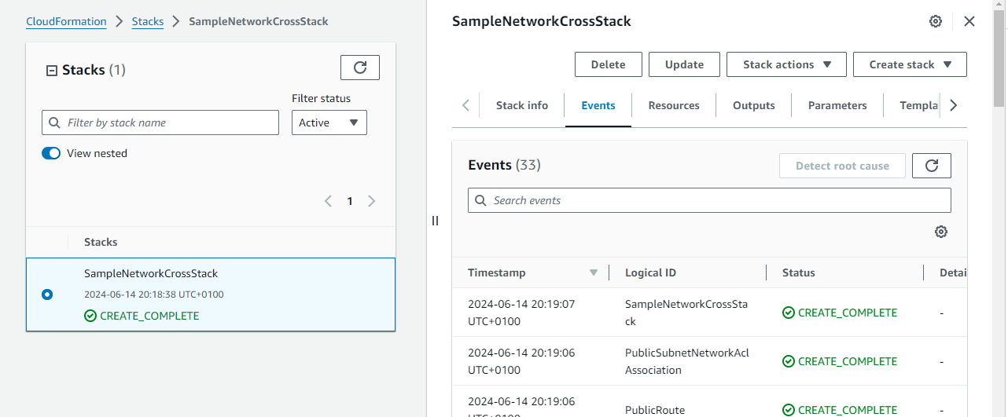

**STEP #2**

**1 -1 Deploy a template in us-west-2 region**

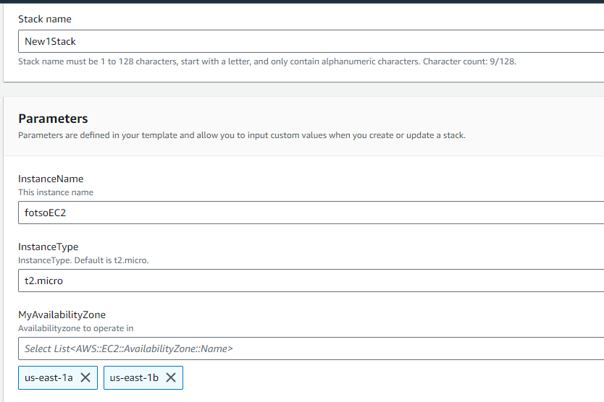

SECOND STACK

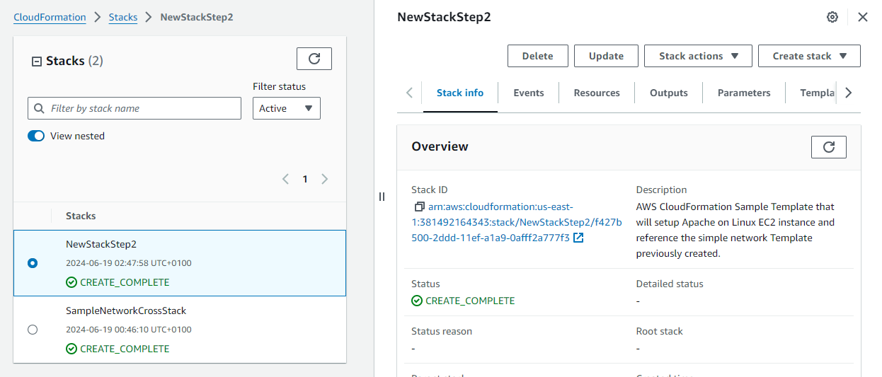

**2- Reference all available variable**

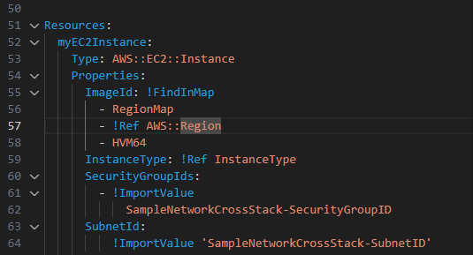

**EC2 LAUCHED WITH THE TEMPLATE**

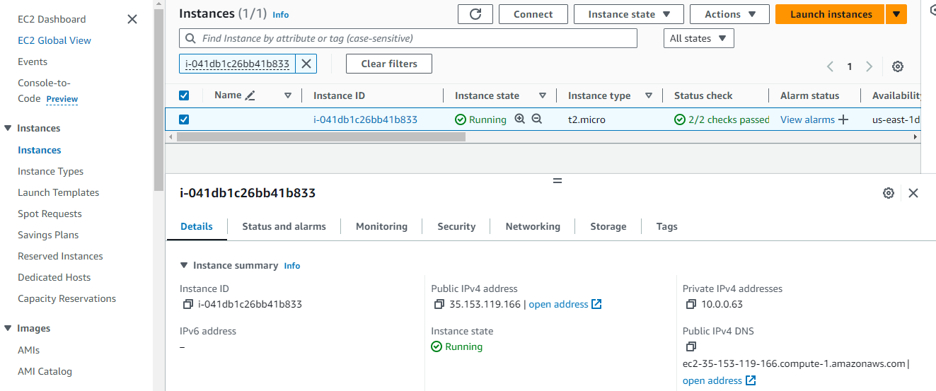

**3- Create a mapping fonction**

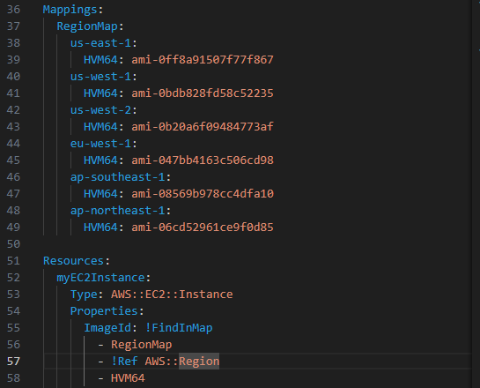

**4- Create parameters**

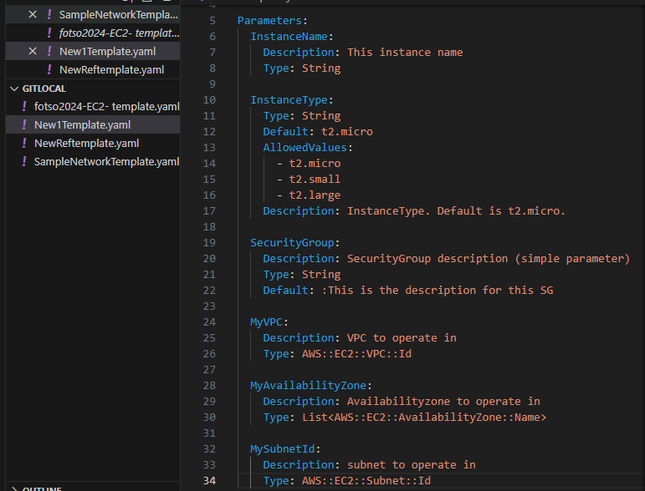

**1 -2 Elastic IP**

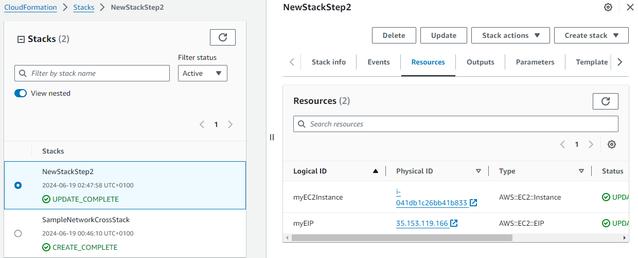

**5 Output values of the PrivateIPv4 address and the DNS Name**

